Group 4

Anuradha Vishwapriya Niradi

Harshitha Mandru

Sravya Garlapti

Sravya Bussoli

**Bon Viveur**

**CSCE 5340 SOfwatre Engineering**

Table of Contents

1. Introduction 3

1.1 Purpose 3

1.2 Scope 3

2 Overall structure of the website 4

2.1 Admin 5

2.2 Vendor 5

2.3 Customer 5

2.4 Web Browser 5

2.5 Web Server 6

2.6 PHP server 6

2.7 Database 6

3 Overall description 7

3.1 Customer registration page 7

3.2 Vendor registration page 8

3.3 Login page 9

3.4 Region and Cuisine 9

3.5 Feedback form 10

4 System Requirements 11

4.1 Non-functional Requirements 11

4.1.1 Usability 11

4.1.2 Performance 11

4.1.3 Maintainability 11

4.1.4 Security 11

4.1.5 Availability 11

4.1.6 Extensibility 11

4.2 Functional Requirements 12

4.2.1 ADMIN 12

4.2.2 VENDOR 12

4.2.3 CUSTOMER 13

4.3 Interfaces 13

5 Implementation plan 14

5.1 Development phase 1 15

5.2 Development phase 2 15

5.3 Development phase 3 15

6 References 17

**TABLE OF FIGURES**

Figure 1: Structure of the system 4

Figure 2: Customer registration page 8

Figure 3: Vendor registration page 8

Figure 4: Login Page 9

Figure 5: Feedback form 10

Figure 6: Process flow of the system 14

# Introduction

United States of America is the second most common destination for Indians for job opportunities, higher studies and there are around 3 million Indians residing in USA as of now. The Indian population include students, working bachelors and families. As India, Indian food is also diverse. For some people, food is not just a basic need, it is a memory, happiness or may be something else! This is an attempt to make people happy who enjoy food. There are mobile applications and websites that will have a list of restaurants in a region based on zip code that people use to order their choice of food. Such applications and website include GrubHub, Favor, Postmates, UberEats, DoorDash etc. We are trying to develop a website for Indians residing in few regions in the state of Texas that provides food cooked by Indian families. This website will provide different cuisine and families can sell their authentic dish to other Indians.

## Purpose

The main purpose of developing this website is Women empowerment. Most of the Indian women who are either citizens or green card holders may not be working in companies and this website helps them in being independent financially. We are trying to include only authentic dishes to make the website special as we have Indian restaurants and temple cafeterias in most of the places which provide normal Indian food.

## Scope

We have websites and applications like GrubHub, Favor, Postmates, UberEats, DoorDash that help people pick restaurants in a particular region and get food delivered by third parties like Uber but we don’t have any website that takes orders and lets anybody to sell their food to people. This website is similar such applications, but it provides food cooked by Indian families that can be orders by anybody. For now, we have included only few regions in Texas such as Dallas, Irving, Arlington, Fort Worth, Plano and Frisco with North Indian and South Indian cuisine. Further we can extend the website to other regions or states and with other cuisines like Chinese, Mediterranean, Mexican etc.

# Overall structure of the website

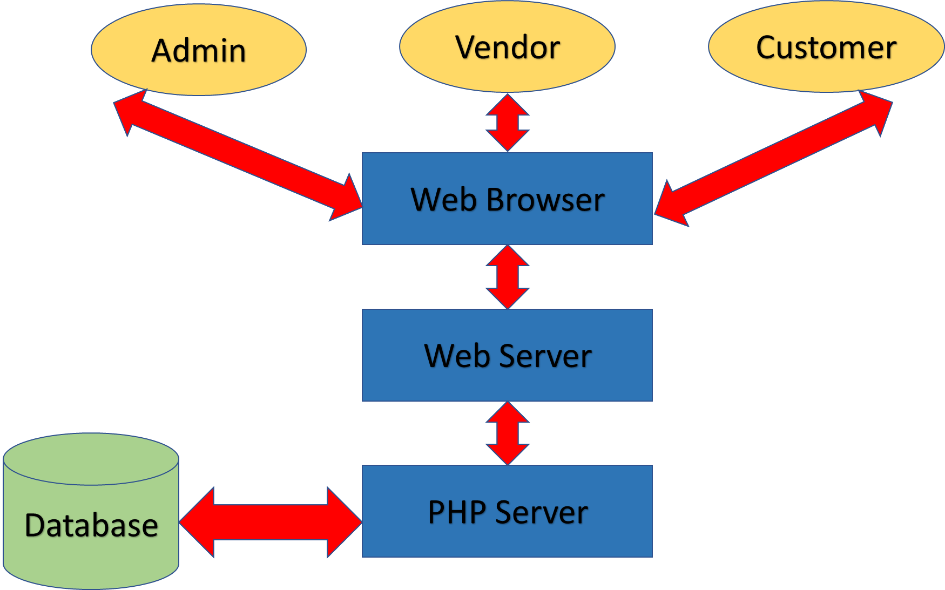

Figure 1: Structure of the system

In our system architecture, we majorly have three categories of users. i.e Admin, Customer and Vendor. Whenever a user needs to access the website, users first interact with web browser. The web browser then redirects to the web server which is in turn connected to the PHP server. The PHP server is finally connected to the Database which has the user data, retrieves the data and then returns the data to the user.

## **Admin**

Admin is the one who is responsible for the development of website. He creates and manages the website, collects the payment, manages the menu, collects the feedback from customer; make sure the website functions properly. Admin also needs to make sure that web site content is fresh, backed up and fully functional. An admin should also make sure that the user interface (UI) is easy to understand and efficient.

## **Vendor**

A vendor is a person who sell their food at our website. Vendor must first register to website; he is responsible to select the menu and decides the preparation time. Whenever customer orders food, vendor will cook the food and keep it ready so that customers can come and pick up the food. Vendor is also responsible for selecting their best-prepared dishes.

## Customer

Customer is the one who orders food online in website, by selecting the food from menu, and then makes the payment. He is also responsible for picking up the food wherever the food is ready. Customer will give rating trough feedback form for food ordered so that vendor can improve the food quality.

## Web Browser

Web browser, also called as browser, is a software that is used to access the website. A browser lets a user to access different websites and perform different activities on website. The major functionality of a browser is to fetch the information requested by the user and then display the fetched information on a user’s device.

The web browser works as follows: whenever a user enters a URL into the browser, the browser retrieves them using HTTP protocol. When we user uses https: then for security and privacy purposes the communication between the web browser and server is encrypted. Once the web page is retrieved, the browser’s rendering engine displays the requested information on the user’s device.

## Web Server

* Web server is used so that admin can use and access files. HTTP server is a software that understands URL’s and HTTP. It is easily accessed through domain names of websites.
* For publishing any website, we need either static or dynamic web server.
* Static web server consists of computer hardware with an HTTP server. It is known as static because server sends host files as it is to the browser.
* Dynamic web server consists same as static web server with added software, most commonly a Database. It is known as Dynamic because server updates files before sending to the web browser via HTTP server.

## PHP server

* While working with php files, when a web server gets a request from a php file, then the server sends the HTML statements as they are, but the PHP statements are processed by the PHP server before sending them to the requestor.
* PHP server is not integrated with all servers but works well with most of the web servers.

## Database

A database is nothing but an organized collection of data which is stored and accessed electronically by the computer. Database stores information about Vendor details like Name, Address, Contact number and best-prepared dishes. It also stores customer details like name and phone number.

# Overall description

Bon Viveur is a French word which means a person who loves food and this project is a website development for such people who miss their home food far away from home. The website will have 6 regions (as of now)-Dallas, Fort Worth, Arlington, Plano, Frisco and Irving, which will have actual families as vendors who will cook their special food and take orders from their menu provided on the website while the customer can order his choice depending upon his region and pick up the food.

Preparation time will be specified in the menu for each dish. We can use a third party to deliver the food which is future scope of the project. We have narrowed down the food cuisine to India and regions in Texas since we are in Texas and starting up. The languages that we will be using are PHP 7, HTML5, MySQL, CSS since these are used in Front-end development projects.

The prototype of website and its pages is shown below. At it’s an e-commerce website, we will have registration page for both customer and vendor. Then comes the login page. We have a tab called **region** which a customer selects depending upon his location. And then the cuisine tab which has two options and then in each option there are different states. We also have feedback form for the customer to rate the vendor and the quality of his food.

## Customer registration page

Figure 2 customer registration page. The customer enters his complete details, username, email address, phone number, etc. When he clicks the **signup button**, his account is created, and his details are added to the database. If a user is already registered, he can click on **Sign In** link, then he is redirected to the login page.

Figure : Customer registration page

## Vendor registration page

Figure 3: Vendor registration page

Figure 3 the vendor registration page. The vendor enters his complete details, username, email address, phone number, address, etc. The vendor needs to enter his address as the customer has to pick up the food from the vendor’s place. When he clicks the **signup button**, his account is created, and his details are added to the database. If a user is already registered, he can click on **Sign In** link, then he is redirected to the login page.

## Login page

Figure 4: Login Page

Figure 4 the login page. Once the user registers to the website, he can login to the website with the username and password. When the user clicks on the **Sign In** button, the browser authenticates the credentials and logs him into the website if the credentials are valid. If the user is not registered to the website, he can click on the **Sign-up** link and then he is redirected to the registration page.

## Region and Cuisine

As described earlier we have 5 regions in Texas in which vendors are registered with their menu and for which we have north and South Indian Cuisine under Cuisine section which is again divided into certain states of India as mentioned in the drop-down menu in the picture. The below picture shows the rough idea of the cuisine options.

## Feedback form

We have feedback form for the customer to rate the dish that he had ordered. This feedback form will help vendor in getting to know customers opinion about his dish and its quality. The form will have fields as shown below.

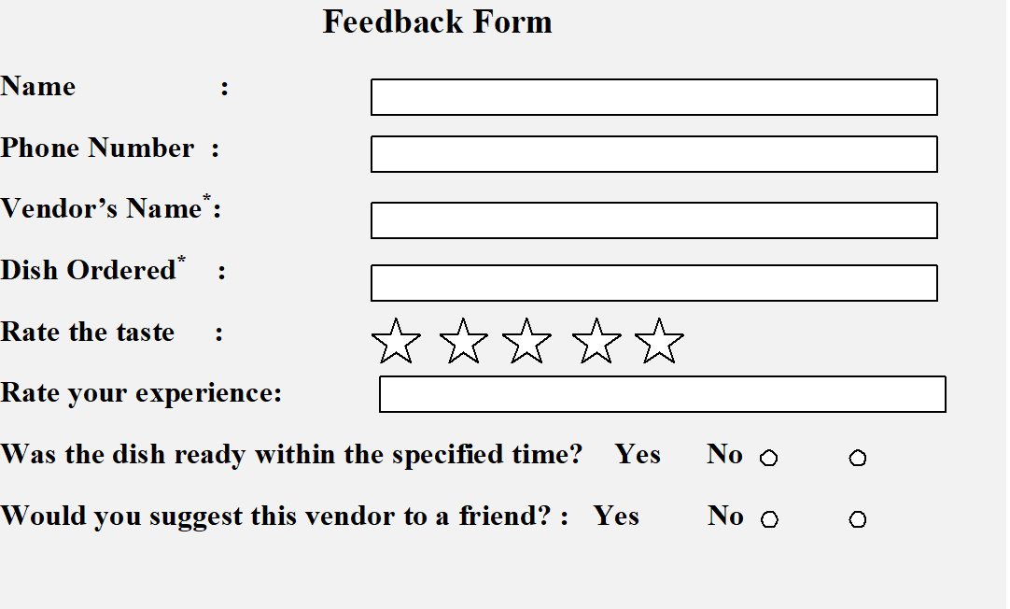

Figure 5: Feedback form

# System Requirements

## Non-functional Requirements

Non-functional requirements define the quality attribute of a software system and represent a set of standards which judge the operations of a system. For example, how fast does a website load? They are crucial to the usability and efficiency of the entire software system. If the system fails to meet these requirements, then the system fails to satisfy user needs.

Non-functional requirements enable us to limit system design across the different agile backlogs. For example, a website should load in 2 seconds even if there are more than 10000 number of simultaneous users. Non-functional requirements are as critical as functional requirements.

### Usability

It is very easy to use. Any person can easily choose the dishes they like and also make the orders.

### Performance

It performs any task in less than a second. It allows multiple users to access the website at the same time without downgrading the performance.

### Maintainability

It is very easy to restore it, and this can be done in less time if at all there is a crash because the website also has a backup code designed.

### Security

It protects the details of the customers and also the banking details. Only admin has the access to view these details.

### Availability

This website is available to the users 24*7.

### Extensibility

This website can be further extended for some more requirements if there is a demand.

## Functional Requirements

Functional requirement defines a system and it describes the functions a software that it must perform in terms of inputs, behavior and outputs. It can be calculation, information manipulation, user interaction, or any other particular features that define what a system is likely to conduct. Requirements for functional software assist you capture the system's intended behavior.

### Admin

Has the centralized authority to the website.

1. Accepts customer orders

Bon Viveur is a website that deals with food orders that can be picked up. So, it will be able to accept all the orders made by the customers.

1. Displays all vendor’s information

The website will store the details of any person who registers himself as the vendor. It immediately displays this information so that the customers can view and order from this vendor if they like.

1. Shows payment details

As soon as the order is confirmed and the payment is made, it immediately displays the invoice/receipt so that there will be a proof for customers, vendors and also the admin.

### Vendor

A person who sells the food items

1. Register

Must enter the details like name, address, phone number and the dish he/she wants to sell.

1. Login

He/she should use the website with the credentials given while registering.

1. Check for new orders

He/she should keep checking if there is any order placed by the customer.

1. Respond

Should give a reply to the customer based on the request made.

1. Update details

They can update their details and change password whenever they want to.

### Customer

A person who places orders

1. Register

Must enter the details like name, address, phone number and the dish he/she wants to sell.

1. Login

Should use the website with the credentials given while registering.

1. Place an order

Whenever he/she comes across the dish they like, they can immediately place an order.

## Interfaces

We have only software interface as we are developing a website. A software interface connects two software and allows them to communicate with each other as per the requirements of the system. We use MariaDB database for our website and XAMPP control panel. It is the most popular PHP development environment and Apache Friends ' free and open-source internet server solution stack package composed primarily of Apache HTTP Server, MariaDB database, and PHP and Perl programming language scripting interpreters. Since most actual deployments of web servers use the same components as XAMPP, it allows the transition from a local test server to a live server. Below are the software interfaces that will be used.

1. Database: MariaDB
2. Tools Required: XAMPP control panel
3. Technologies used:
4. Front end: HTML, CSS
5. Language: PHP

# Implementation plan

The implementation of the website is divided into three development phases and includes the below given requirements.

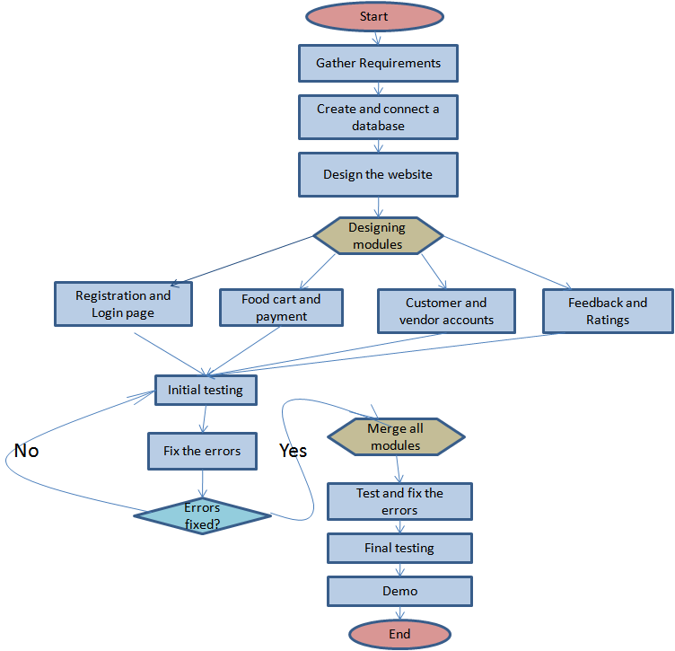

Figure 6: Process flow of the system

## Development phase 1

This phase includes gathering of requirements, database setup and website design which are of priority. Requirements is what a vendor must have in order to take an order from customer and for a customer, what he should have to place an order, and how the website connects the customer to vendor to make the order placement successful. Database setup includes creation of tables for customer, vendor, menu, cart and payment.

Functional requirements for admin are the corresponding requirements for this development phase which are explained above in the section 4.21 requirements section. The website design is also decided in this phase and accordingly the phase 2 is implemented.

## Development phase 2

This phase includes implementation of login page, registration page, vendor details on the respective cuisine page in a region, cart and order details and payment page and integration of all the modules/pages. The login page and registration page will have necessary field for creating the account for both customer and vendor.

The region will have 2 cuisines viz., North and South and the cuisine will have different vendors with their respective menu of dishes. Once the dish is selected from the menu, it can be added to the cart and then takes the process to payment. We are trying to include PayPal for the payments.

Functional requirements for Customer and Vendor in 4.22 and 4.23 of Requirement section are the corresponding requirements for this development phase.

## Development phase 3

This phase includes implementing security features two factor authentication to the website to protect it from attacks such as SQL injection, XSS (Cross Site Scripting) and other attacks concerned with the website. Before including the security features, the website will be testes initially for errors and fix the same. After adding up the security features the website will be tested again to check if it is working as per the design and requirements. Necessary changes will be made depending upon the testing results.

Non-functional requirements are the corresponding requirements for this development phase which in explained in the 4.1 section of the requirements section.

# References

1. <https://en.wikipedia.org/wiki/XAMPP>
2. <https://www.dummies.com/programming/php/how-php-works/>
3. <https://www.geeksforgeeks.org/web-servers-work/>
4. <https://searchsqlserver.techtarget.com/definition/database-management-system>
5. <https://reqtest.com/requirements-blog/functional-vs-non-functional-requirements/>
6. <https://lvivity.com/functional-and-non-functional-requirements>